**Lab Tasks:**

#### **Lab Task#1:**

For the Boolean function do the following:



Draw logic circuit diagram in the space provided below and implement the circuit on logic trainer.

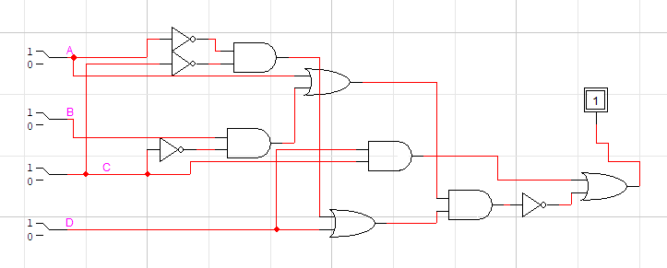

Draw timing diagrams for construction and verification of the circuit

|  |  |  |
| --- | --- | --- |
| Inputs | A | 0000000011111111 |
| B | 0000111100001111 |
| C | 0011001100110011 |
| D | 0101010101010101 |
| Output | F1(expected result) | 1111001110111011 |
| F1(implementation  result) | 1111001110111011 |

#### 

**Lab Task#2:** For the Boolean function do the following:



Draw logic circuit diagram in the space provided below and implement the circuit on logic trainer.

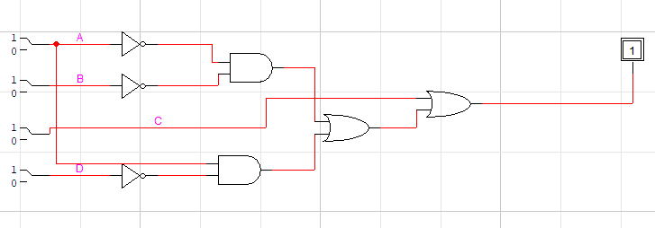

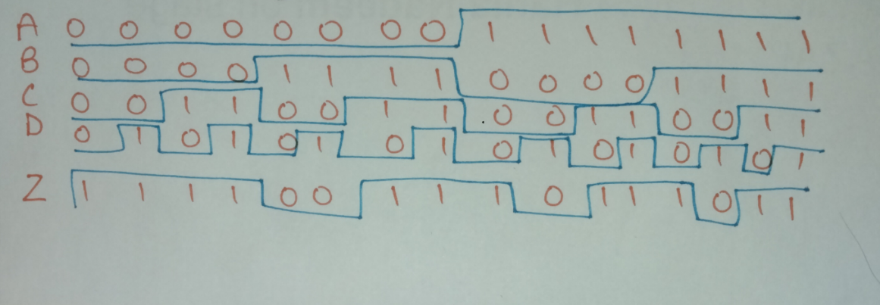

Draw timing diagrams for construction and verification of the circuit

|  |  |  |
| --- | --- | --- |
| Inputs | A | 0000000011111111 |
| B | 0000111100001111 |
| C | 0011001100110011 |
| D | 0101010101010101 |
| Output | F2(expected result) | 1111001110111011 |
| F2(implementation  result) | 1111001110111011 |

#### **Lab Task#3:**



Write the Boolean expression for the logic circuit in Figure 12. Also implement the given circuits on breadboard and draw Truth tables:

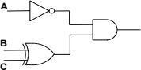

Figure 12: Combinational Circuit

Z=A’(B^C)

|  |  |  |  |  |  |
| --- | --- | --- | --- | --- | --- |
| A | B | C | A’ | BC | X |
| 0 | 0 | 0 | 1 | 0 | 0 |
| 0 | 0 | 1 | 1 | 1 | 1 |
| 0 | 1 | 0 | 1 | 1 | 1 |
| 0 | 1 | 1 | 1 | 0 | 0 |
| 1 | 0 | 0 | 0 | 0 | 0 |
| 1 | 0 | 1 | 0 | 1 | 0 |
| 1 | 1 | 0 | 0 | 1 | 0 |
| 1 | 1 | 1 | 0 | 0 | 0 |

**Task 4:**

Prove that the circuits are equal via the laws mentioned above and via the logic trainer. Make sure to only create both circuits.

1. **A + AB = A**

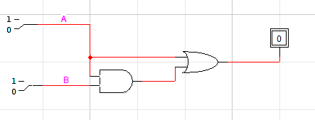

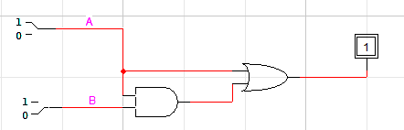

1. **A + ĀB = A + B**

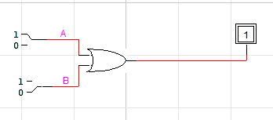

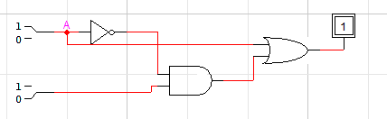

1. **(A + B) (A + C) = A + BC**

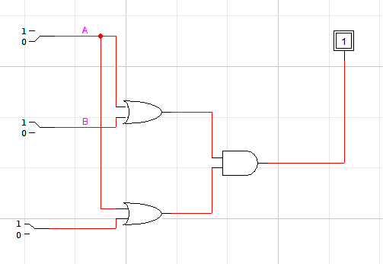

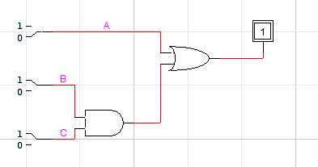

1. **A ⊙ (A ⊙ B) = B**

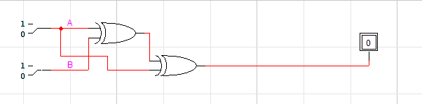

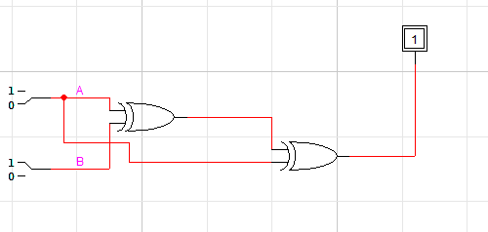

**Task 5:**

Implement the mentioned logic using only two XOR gates.



